Creating an Alpine Docker Container
- Last Updated : 31 Oct, 2020
Alpine is a Linux Distribution. Docker provides you with the low sized (only 5 MB) Alpine Linux Image. The Alpine Linux Docker Image has advantages over the Ubuntu Image because of its relatively lower size and it provides almost all the functionalities that an Ubuntu Image can. In this article, we will see how to build an Alpine Linux Image. We will try to install MySQL client, Python 3, and Firefox inside the Alpine Linux Docker Container as well.
To create the Alpine Docker Container follow the below steps:

Step 1: Pull and Run the Alpine Image
To run the Alpine Image Docker Container, you can use the Docker run command.
sudo docker run -it alpine:3

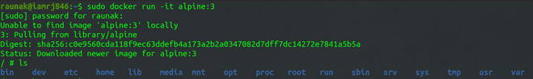
Running the Alpine Container
Once the Image is loaded, it opens up the shell for you automatically.

Step 2: Install Python 3
To install python 3 inside the Alpine Container, you can use the apk add command inside the shell.

apk add python3

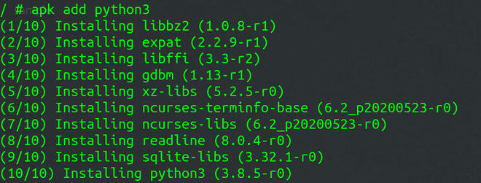
Installing Python 3

Step 3: Install MySQL inside the Container
You can install the My-SQL client using the following command.
apk add mysql-client

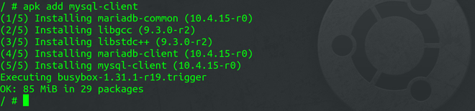
My-SQL Client

Step 4: Install Firefox
To install Firefox inside the Container, you can use the following command.
apk add firefox

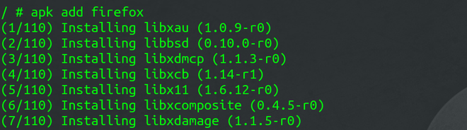
Installing Firefox
Step 5: Commit the changes in the Image
You need the Container Id to commit the changes in the Image.
To find the Container ID, use this command.
sudo docker ps -a

Copy the Container ID and paste it in this command.
sudo docker commit eacdf78d1bde my-alpine

“my-alpine” is the new image name.
You can verify by listing the images.
sudo docker images

https://www.geeksforgeeks.org/creating-an-alpine-docker-container/

How to build Your First Alpine Docker Image and Push it to DockerHub

Tested Infrastructure
Platform | Number of Instance | Reading Time
Play with Docker | 1 | 5 min

Pre-requisite
- Create an account with DockerHub
- Open PWD Platform on your browser
- Click on Add New Instance on the left side of the screen to bring up Alpine OS instance on the right side
Under this tutorial we will see how to build our own first alpine based Docker Image.
$ docker run -dit alpine sh
620e1bcb5ab6e84b75a7a5c35790a77691112e59830ea1d5d85244bc108578c9
[node4] (local) root@192.168.0.20 ~
$ docker ps
CONTAINER ID IMAGE COMMAND CREATED STATUS PORTS NAMES
620e1bcb5ab6 alpine "sh" 3 seconds ago Up 2 seconds keen_alba
ttani
[node4] (local) root@192.168.0.20 ~
$ docker attach 62
/ #
/ #
/ # cat /etc/os-release
NAME="Alpine Linux"
ID=alpine
VERSION_ID=3.9.2
PRETTY_NAME="Alpine Linux v3.9"
HOME_URL="https://alpinelinux.org/"
BUG_REPORT_URL="https://bugs.alpinelinux.org/"
/ #

Updating APK Packages
/ # apk update
fetch http://dl-cdn.alpinelinux.org/alpine/v3.9/main/x86_64/APKINDEX.tar.gz
fetch http://dl-cdn.alpinelinux.org/alpine/v3.9/community/x86_64/APKINDEX.tar.gz
v3.9.2-21-g3dda2a36ce [http://dl-cdn.alpinelinux.org/alpine/v3.9/main]
v3.9.2-19-gfdf726d41a [http://dl-cdn.alpinelinux.org/alpine/v3.9/community]
OK: 9756 distinct packages available
/ # ^
/ # apk add git
(1/7) Installing ca-certificates (20190108-r0)
(2/7) Installing nghttp2-libs (1.35.1-r0)
(3/7) Installing libssh2 (1.8.0-r4)
(4/7) Installing libcurl (7.64.0-r1)
(5/7) Installing expat (2.2.6-r0)
(6/7) Installing pcre2 (10.32-r1)
(7/7) Installing git (2.20.1-r0)
Executing busybox-1.29.3-r10.trigger
Executing ca-certificates-20190108-r0.trigger
OK: 20 MiB in 21 packages
/ #

Now lets come out of it by Ctrl+P+Q and commit the changes
$ docker ps
CONTAINER ID IMAGE COMMAND CREATED STATUS PORTS NAMES
620e1bcb5ab6 alpine "sh" 4 minutes ago Up 4 minutes keen_alba
ttani
[node4] (local) root@192.168.0.20 ~
$ docker commit -m "Added GIT" 620 ajeetraina/alpine-git
sha256:9a8cd6c3bd8761013b2b932c58af2870f5637bfdf4227d7414073b0458ed0c54
[node4] (local) root@192.168.0.20 ~
$ docker images
REPOSITORY TAG IMAGE ID CREATED SIZE
ajeetraina/alpine-git latest 9a8cd6c3bd87 11 seconds ago 31.2MB
ubuntu latest 94e814e2efa8 3 days ago 88.9MB
alpine 3.6 43773d1dba76 7 days ago 4.03MB
alpine 3.7 6d1ef012b567 7 days ago 4.21MB
alpine 3.8 dac705114996 7 days ago 4.41MB
alpine 3.9 5cb3aa00f899 7 days ago 5.53MB
alpine latest 5cb3aa00f899 7 days ago 5.53MB
There you see a new image just created.

Time to tag the image
$ docker tag --help

Usage: docker tag SOURCE_IMAGE[:TAG] TARGET_IMAGE[:TAG]

Create a tag TARGET_IMAGE that refers to SOURCE_IMAGE
[node4] (local) root@192.168.0.20 ~
$ docker tag ajeetraina/alpine-git:latest ajeetraina/alpine-git:1.0
$ docker images
REPOSITORY TAG IMAGE ID CREATED SIZE
ajeetraina/alpine-git 1.0 9a8cd6c3bd87 2 minutes ago 31.2MB
ajeetraina/alpine-git latest 9a8cd6c3bd87 2 minutes ago 31.2MB
ubuntu latest 94e814e2efa8 3 days ago 88.9MB
alpine 3.6 43773d1dba76 7 days ago 4.03MB
alpine 3.7 6d1ef012b567 7 days ago 4.21MB
alpine 3.8 dac705114996 7 days ago 4.41MB
alpine 3.9 5cb3aa00f899 7 days ago 5.53MB
alpine latest 5cb3aa00f899 7 days ago 5.53MB

Pushing it to DockerHub
$ docker login
Login with your Docker ID to push and pull images from Docker Hub. If you don't have a Docker ID, head over to https://hub.docker
.com to create one.
Username: ajeetraina
Password:
WARNING! Your password will be stored unencrypted in /root/.docker/config.json.
Configure a credential helper to remove this warning. See
https://docs.docker.com/engine/reference/commandline/login/#credentials-store

Login Succeeded
[node4] (local) root@192.168.0.20 ~
$ docker push ajeetraina/alpine-git:1.0
The push refers to repository [docker.io/ajeetraina/alpine-git]
3846235f8c17: Pushed
bcf2f368fe23: Mounted from library/alpine
1.0: digest: sha256:85d50f702e930db9e5b958387e667b7e26923f4de340534085cea184adb8411e size: 740
[node4] (local) root@192.168.0.20 ~
Next » Building Docker Image from Scratch
https://dockerlabs.collabnix.com/beginners/building-your-first-alpine-container.html

Use Docker and Alpine Linux to build lightweight containers

Alpine Linux won't always be the right OS choice for IT teams, but it's an option worth consideration when lightweight container images are the goal.


By
- Stuart Burns
Published: 28 Oct 2020
When it comes to Docker, sometimes less is more -- a maxim that applies especially to the base OS images installed in each Docker image.
The use of a lightweight image -- one with less than 200 MB -- can result in significant resource and cost savings when used alongside optimized applications. A lightweight image also takes less time to deploy compared to a larger one, as it boots up faster.

Most OS images are lightweight, with minimal compute resource requirements. But others, such as Windows containers, are huge. Alpine Linux is a super lightweight Linux distribution that's useful for Docker containers.
In this Docker and Alpine Linux tutorial, we'll build an Nginx web server that demonstrates how small a Docker container image can be.
Author's note: The container image we build in this Docker and Alpine Linux tutorial is not production-ready.

Alpine Linux as an OS option
As Figure 1 demonstrates, a container image can be less than 6 MB with an Alpine Linux OS -- far more lightweight than one with an Ubuntu OS.
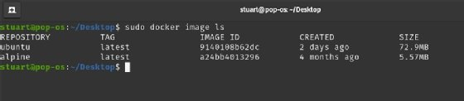
Stuart Burns
Figure 1. This list compares Alpine Linux versus Ubuntu Docker image sizes.
Alpine Linux is extremely bare bones, as it doesn't come with the niceties most base images include, such as a GUI or systemd. This means admins, however, can't simply swap out their current OS configuration, such as Ubuntu, for Alpine Linux.

How to work with Alpine Linux
There is an official Alpine Linux image available, along with various tags for various release versions. By default, there is only a root account.
Alpine Linux comes with BusyBox, a suite of Unix utilities. To run a base Alpine Linux image, use the command docker run with flags to initialize and tag for Alpine. Specify /bin/sh to run a BusyBox shell:
docker run -i -t alpine /bin/sh
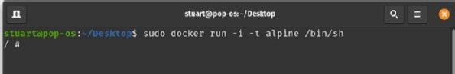
Stuart Burns
Figure 2. This command runs a rudimentary Alpine Linux-based Docker container.
For the most part, default setup with BusyBox is straightforward. However, if you want to run the Unix shell Bash, use apk, the package manager for Alpine. To add Bash to the Dockerfile, use apk add bash. The command apk add is how to add packages.
Tell the container to run Bash with a similar command setup -- this time with /bin/bash rather than bin/sh:
sudo docker run -i -t alpine /bin/bash
To remove packages, use apk del <package> name. To locate a package, perform a simple apk search. More details on packages and configurations can be found here.
There are many web servers available to run with Alpine Linux in a Docker container, but the smallest, lightest and arguably quickest is Nginx. To install Nginx with apk use apk add nginx.
With apk, we have all the tools to build a Dockerfile for the container image. The super light Dockerfile below shows a basic setup, with files copied, as needed. For the sake of simplicity, we use several RUN commands, rather than merge them, and create a smaller image.
FROM alpine:latest
LABEL maintainer="stuart@newlymintedmedia.com"
RUN apk add nginx
RUN mkdir -p /run/nginx
RUN touch /run/nginx/nginx.pid
RUN adduser -D -g 'www' www
RUN mkdir /www
RUN chown -R www:www /var/lib/nginx
RUN chown -R www:www /www
COPY nginx.conf /etc/nginx/nginx.conf
COPY index.html /www
RUN ["./usr/sbin/nginx"]
This Dockerfile is enough to start the web server. It won't, however, show much, as we have excluded the Nginx configuration.
Alpine Linux does have a service management system, OpenRC, as an optional extra, but it is not necessary in Docker images. Instead, use the Nginx binary files to run OpenRC via the command line, as it only has one job.

Go beyond the basics
At this point in the Docker and Alpine Linux tutorial, the container will run -- but, again, it is not production-ready; we have simply created a functioning Alpine Linux image with a base Nginx server that will display the base webpage. You can use the Dockerfile to create a more tailored, bespoke image for testing and deployment.
Depending on how you want to roll your image, you could use the copy command to copy HTML source files into the image. The files can stand alone without a central set of files -- such as HTML or JavaScript -- that are network-mounted. While more resilient in this configuration, the container image does have to be recomposed with every source code change.
As mentioned above, IT teams can't swap a base image from Ubuntu or another distribution to Alpine Linux and expect it to work interchangeably. But if teams want super lightweight containers, learning how to build a Dockerfile and executable container with Alpine Linux might be worth the investment.
https://searchitoperations.techtarget.com/tutorial/Use-Docker-and-Alpine-Linux-to-build-lightweight-containers

First Alpine Linux Containers
• @jimcodified
In this lab you will run a popular, free, lightweight container and explore the basics of how containers work, how the Docker Engine executes and isolates containers from each other. If you already have experience running containers and basic Docker commands you can probably skip this intro exercise.

Concepts in this exercise:
- Docker engine
- Containers & images
- Image registries and Docker Hub
- Container isolation

Tips:
Code snippets are shown in one of three ways throughout this environment:
- Code that looks like this is sample code snippets that is usually part of an explanation.
- Code that appears in box like the one below can be clicked on and it will automatically be typed in to the appropriate terminal window:
uname -a
- Code appearing in windows like the one below is code that you should type in yourself. Usually there will be a unique ID or other bit your need to enter which we cannot supply. Items appearing in <> are the pieces you should substitute based on the instructions.
docker container start <container ID>

1.0 Running your first container
It’s time to get your hands dirty! As with all things technical, a “hello world” app is good place to start. Type or click the code below to run your first Docker container:
docker container run hello-world
That’s it: your first container. The hello-world container output tells you a bit about what just happened. Essentially, the Docker engine running in your terminal tried to find an image named hello-world. Since you just got started there are no images stored locally (Unable to find image...) so Docker engine goes to its default Docker registry, which is Docker Hub, to look for an image named “hello-world”. It finds the image there, pulls it down, and then runs it in a container. And hello-world’s only function is to output the text you see in your terminal, after which the container exits.
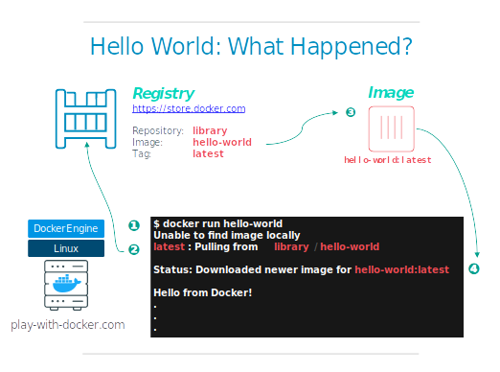
If you are familiar with VMs, you may be thinking this is pretty much just like running a virtual machine, except with a central repository of VM images. And in this simple example, that is basically true. But as you go through these exercises you will start to see important ways that Docker and containers differ from VMs. For now, the simple explanation is this:
- The VM is a hardware abstraction: it takes physical CPUs and RAM from a host, and divides and shares it across several smaller virtual machines. There is an OS and application running inside the VM, but the virtualization software usually has no real knowledge of that.
- A container is an application abstraction: the focus is really on the OS and the application, and not so much the hardware abstraction. Many customers actually use both VMs and containers today in their environments and, in fact, may run containers inside of VMs.

1.1 Docker Images
In this rest of this lab, you are going to run an Alpine Linux container. Alpine is a lightweight Linux distribution so it is quick to pull down and run, making it a popular starting point for many other images.
To get started, let’s run the following in our terminal:
docker image pull alpine
The pull command fetches the alpine image from the Docker registry and saves it in our system. In this case the registry is Docker Hub. You can change the registry, but that’s a different lab.
You can use the docker image command to see a list of all images on your system.
docker image ls
REPOSITORY TAG IMAGE ID CREATED VIRTUAL SIZE
alpine latest c51f86c28340 4 weeks ago 1.109 MB
hello-world latest 690ed74de00f 5 months ago 960 B

1.1 Docker Container Run
Great! Let’s now run a Docker container based on this image. To do that you are going to use the docker container run command.
docker container run alpine ls -l
total 48
drwxr-xr-x 2 root root 4096 Mar 2 16:20 bin
drwxr-xr-x 5 root root 360 Mar 18 09:47 dev
drwxr-xr-x 13 root root 4096 Mar 18 09:47 etc
drwxr-xr-x 2 root root 4096 Mar 2 16:20 home
drwxr-xr-x 5 root root 4096 Mar 2 16:20 lib
......
......
While the output of the ls command may not be all that exciting, behind the scenes quite a few things just took place. When you call run, the Docker client finds the image (alpine in this case), creates the container and then runs a command in that container. When you run docker container run alpine, you provided a command (ls -l), so Docker executed this command inside the container for which you saw the directory listing. After the ls command finished, the container shut down.
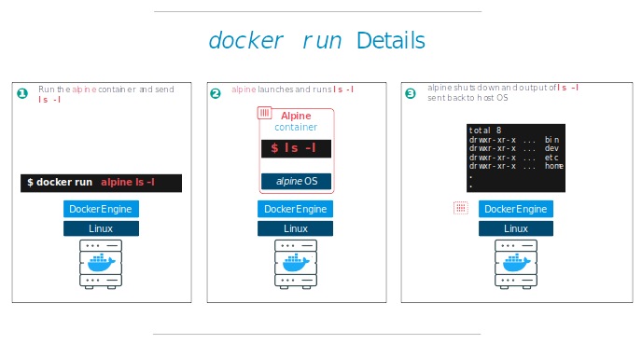
The fact that the container exited after running our command is important, as you will start to see. Let’s try something more exciting. Type in the following:
docker container run alpine echo "hello from alpine"
And you should get the following output:
hello from alpine
In this case, the Docker client dutifully ran the echo command inside our alpine container and then exited. If you noticed, all of that happened pretty quickly and again our container exited. As you will see in a few more steps, the echo command ran in a separate container instance. Imagine booting up a virtual machine (VM), running a command and then killing it; it would take a minute or two just to boot the VM before running the command. A VM has to emulate a full hardware stack, boot an operating system, and then launch your app - it’s a virtualized hardware environment. Docker containers function at the application layer so they skip most of the steps VMs require and just run what is required for the app. Now you know why they say containers are fast!
Try another command.
docker container run alpine /bin/sh
Wait, nothing happened! Is that a bug? No! In fact, something did happen. You started a 3rd instance of the alpine container and it ran the command /bin/sh and then exited. You did not supply any additional commands to /bin/sh so it just launched the shell, exited the shell, and then stopped the container. What you might have expected was an interactive shell where you could type some commands. Docker has a facility for that by adding a flag to run the container in an interactive terminal. For this example, type the following:
docker container run -it alpine /bin/sh
You are now inside the container running a Linux shell and you can try out a few commands like ls -l, uname -a and others. Note that Alpine is a small Linux OS so several commands might be missing. Exit out of the shell and container by typing the exit command.
Ok, we said that we had run each of our commands above in a separate container instance. We can see these instances using the docker container ls command. The docker container ls command by itself shows you all containers that are currently running:
docker container ls
CONTAINER ID IMAGE COMMAND CREATED STATUS PORTS NAMES
Since no containers are running, you see a blank line. Let’s try a more useful variant: docker container ls -a
docker container ls -a
CONTAINER ID IMAGE COMMAND CREATED STATUS PORTS NAMES
36171a5da744 alpine "/bin/sh" 5 minutes ago Exited (0) 2 minutes ago fervent_newton
a6a9d46d0b2f alpine "echo 'hello from alp" 6 minutes ago Exited (0) 6 minutes ago lonely_kilby
ff0a5c3750b9 alpine "ls -l" 8 minutes ago Exited (0) 8 minutes ago elated_ramanujan
c317d0a9e3d2 hello-world "/hello" 34 seconds ago Exited (0) 12 minutes ago stupefied_mcclintock
What you see now is a list of all containers that you ran. Notice that the STATUS column shows that these containers exited some time ago.
Here is the same output of the docker container ls -a command, shown diagrammatically (note that your container IDs and names will be different):
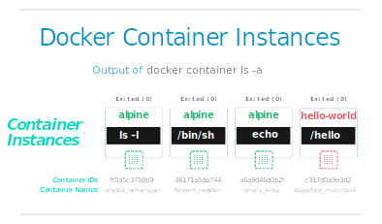
It makes sense to spend some time getting comfortable with the docker run commands. To find out more about run, use docker container run --help to see a list of all flags it supports. As you proceed further, we’ll see a few more variants of docker container run but feel free to experiment here before proceeding.

1.2 Container Isolation
In the steps above we ran several commands via container instances with the help of docker container run. The docker container ls -a command showed us that there were several containers listed. Why are there so many containers listed if they are all from the alpine image?
This is a critical security concept in the world of Docker containers! Even though each docker container run command used the same alpine image, each execution was a separate, isolated container. Each container has a separate filesystem and runs in a different namespace; by default a container has no way of interacting with other containers, even those from the same image. Let’s try another exercise to learn more about isolation.
docker container run -it alpine /bin/ash
The /bin/ash is another type of shell available in the alpine image. Once the container launches and you are at the container’s command prompt type the following commands:
echo "hello world" > hello.txt

ls
The first echo command creates a file called “hello.txt” with the words “hello world” inside it. The second command gives you a directory listing of the files and should show your newly created “hello.txt” file. Now type exit to leave this container.
To show how isolation works, run the following:
docker container run alpine ls
It is the same ls command we used inside the container’s interactive ash shell, but this time, did you notice that your “hello.txt” file is missing? That’s isolation! Your command ran in a new and separate instance, even though it is based on the same image. The 2nd instance has no way of interacting with the 1st instance because the Docker Engine keeps them separated and we have not setup any extra parameters that would enable these two instances to interact.
In every day work, Docker users take advantage of this feature not only for security, but to test the effects of making application changes. Isolation allows users to quickly create separate, isolated test copies of an application or service and have them run side-by-side without interfering with one another. In fact, there is a whole lifecycle where users take their changes and move them up to production using this basic concept and the built-in capabilities of Docker Enteprise. We will explore more of that in later exercises.
Right now, the obvious question is “how do I get back to the container that has my ‘hello.txt’ file?”
Once again run the
docker container ls -a
command again and you should see output similar to the following:
CONTAINER ID IMAGE COMMAND CREATED STATUS PORTS NAMES
36171a5da744 alpine "ls" 2 minutes ago Exited (0) 2 minutes ago distracted_bhaskara
3030c9c91e12 alpine "/bin/ash" 5 minutes ago Exited (0) 2 minutes ago fervent_newton
a6a9d46d0b2f alpine "echo 'hello from alp" 6 minutes ago Exited (0) 6 minutes ago lonely_kilby
ff0a5c3750b9 alpine "ls -l" 8 minutes ago Exited (0) 8 minutes ago elated_ramanujan
c317d0a9e3d2 hello-world "/hello" 34 seconds ago Exited (0) 12 minutes ago stupefied_mcclintock
Graphically this is what happened on our Docker Engine: 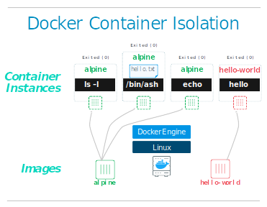
The container in which we created the “hello.txt” file is the same one where we used the /bin/ash shell, which we can see listed in the “COMMAND” column. The Container ID number from the first column uniquely identifies that particular container instance. In the sample output above the container ID is 3030c9c91e12. We can use a slightly different command to tell Docker to run this specific container instance. Try typing:
docker container start <container ID>
- Pro tip: Instead of using the full container ID you can use just the first few characters, as long as they are enough to uniquely ID a container. So we could simply use “3030” to identify the container instance in the example above, since no other containers in this list start with these characters.
Now use the docker container ls command again to list the running containers.
CONTAINER ID IMAGE COMMAND CREATED STATUS PORTS NAMES
3030c9c91e12 alpine "/bin/ash" 2 minutes ago Up 14 seconds distracted_bhaskara
Notice this time that our container instance is still running. We used the ash shell this time so the rather than simply exiting the way /bin/sh did earlier, ash waits for a command. We can send a command in to the container to run by using the exec command, as follows:
docker container exec <container ID> ls
This time we get a directory listing and it shows our “hello.txt” file because we used the container instance where we created that file.
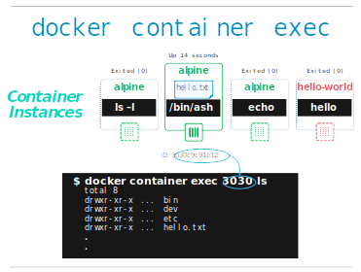
Now you are starting to see some of the important concepts of containers. In the next exercise we will start to see how you can create your own Docker images and how to use a Dockerfile to standardize images such that you can create larger, more complex images in a simple, automated manner.

1.3 Terminology
In the last section, you saw a lot of Docker-specific jargon which might be confusing to some. So before you go further, let’s clarify some terminology that is used frequently in the Docker ecosystem.
- Images - The file system and configuration of our application which are used to create containers. To find out more about a Docker image, run docker image inspect alpine. In the demo above, you used the docker image pull command to download the alpine image. When you executed the command docker container run hello-world, it also did a docker image pull behind the scenes to download the hello-world image.
- Containers - Running instances of Docker images — containers run the actual applications. A container includes an application and all of its dependencies. It shares the kernel with other containers, and runs as an isolated process in user space on the host OS. You created a container using docker run which you did using the alpine image that you downloaded. A list of running containers can be seen using the docker container ls command.
- Docker daemon - The background service running on the host that manages building, running and distributing Docker containers.
- Docker client - The command line tool that allows the user to interact with the Docker daemon.
- Docker Hub - Store is, among other things, a registry of Docker images. You can think of the registry as a directory of all available Docker images. You’ll be using this later in this tutorial.

Where do images get pulled from by default when not found locally?
Docker Trusted Registry
Docker Hub
There is no default
Docker Store

https://training.play-with-docker.com/ops-s1-hello/

